|  |  |
| --- | --- |
|  | **FPT ACADEMY INTERNATIONAL**  **FPT – APTECH COMPUTER EDUCATION** |

**Centre Name: FAT2-HCM**

**Address: 590 Cach Mang Thang 8, District 3, Ho Chi Minh City, Viet Nam.**

🙢★🙠

**Auto Ancillaries Limited**

**Installation Guide**

|  |  |  |
| --- | --- | --- |
| **Supervisor:** | Mr. Hoang Duc Quang | |
| **Semester:** | 3 | |
| **Batch No:** | T1.2109.M1 | |
| **Group No:** | 6 | |
| **Team member:** | **Full name** | **Roll No.** |
| 1. | Tran Cong Thinh | Student1331708 |
| 2. | Tong Nguyen Thai An | Student1331707 |
| 3. | Huynh Ngoc Thai | Student1317113 |

**Month**: Dec **Year**: 2022

1. **Configuration**
2. **Database Configuration**

* Open and Connect Microsoft SQL Server Management Studio 18

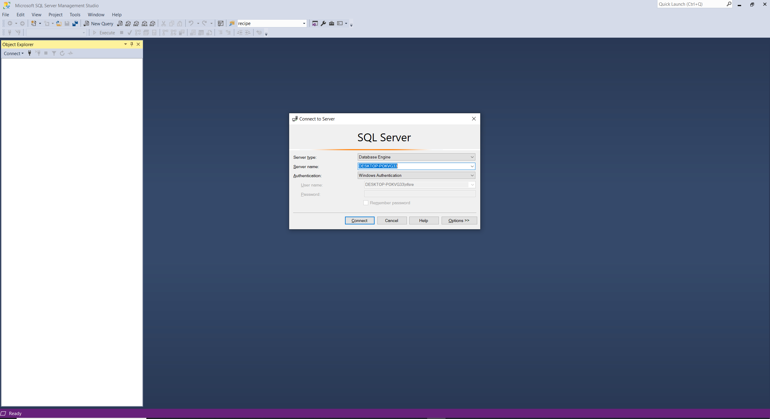

* 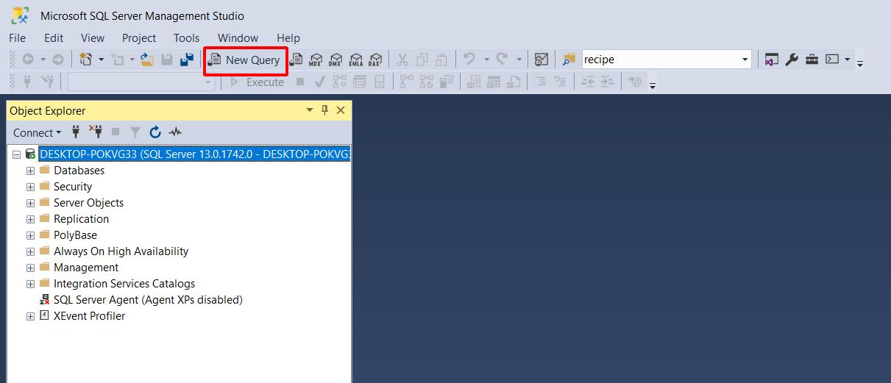Click New Query
* Open folder Group 6 – Auto Ancilaries Limited > db

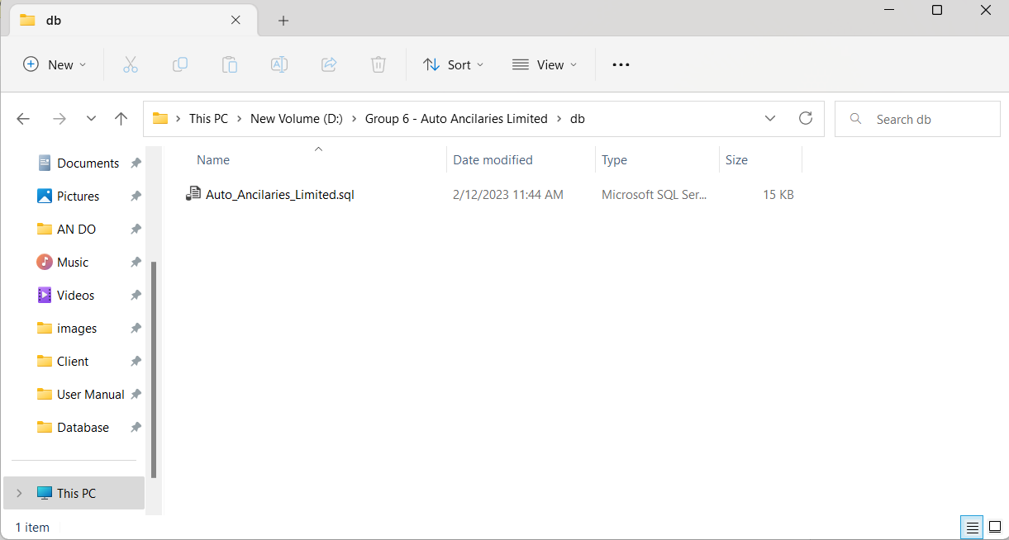

* Open Auto_Ancilaries_Limited database file by Microsoft SQL Server Management Studio 18:

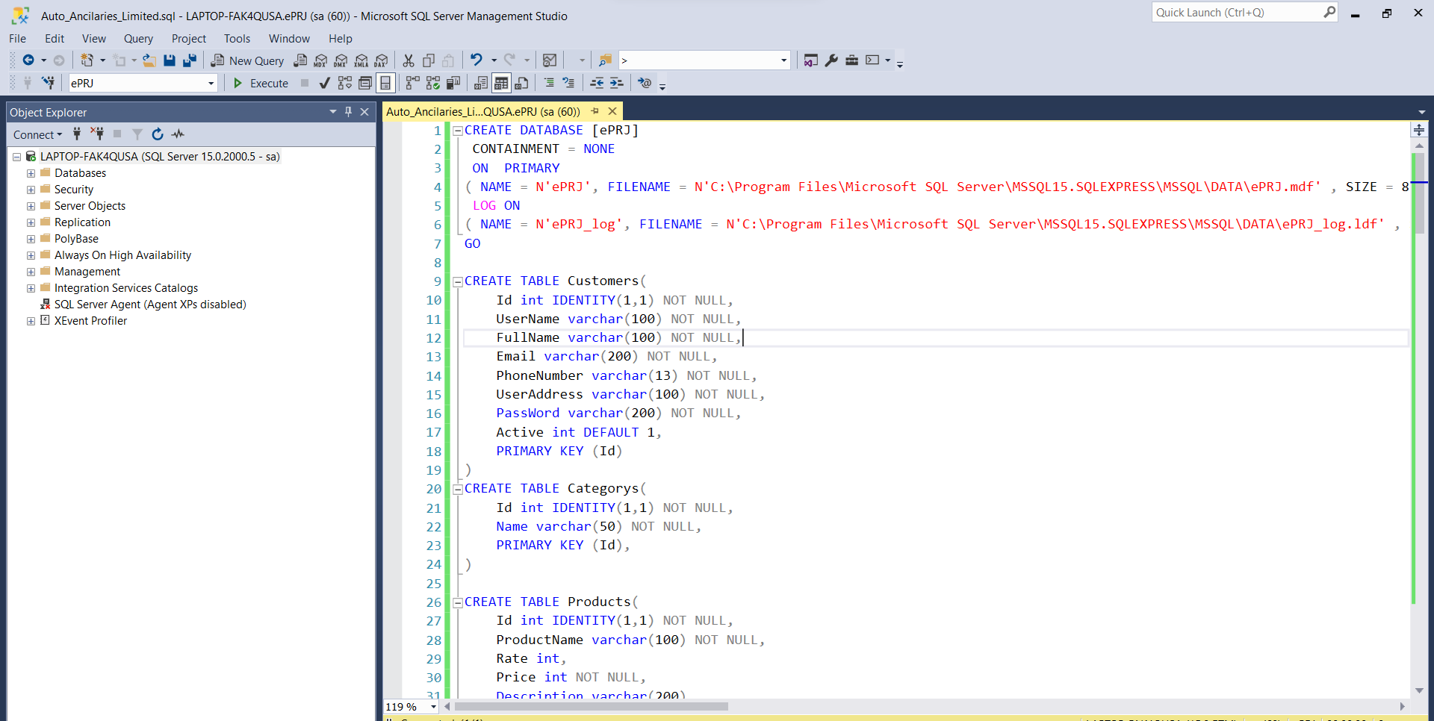

* Ctrl A and F5 to insert database Auto_Ancilaries_Limited:

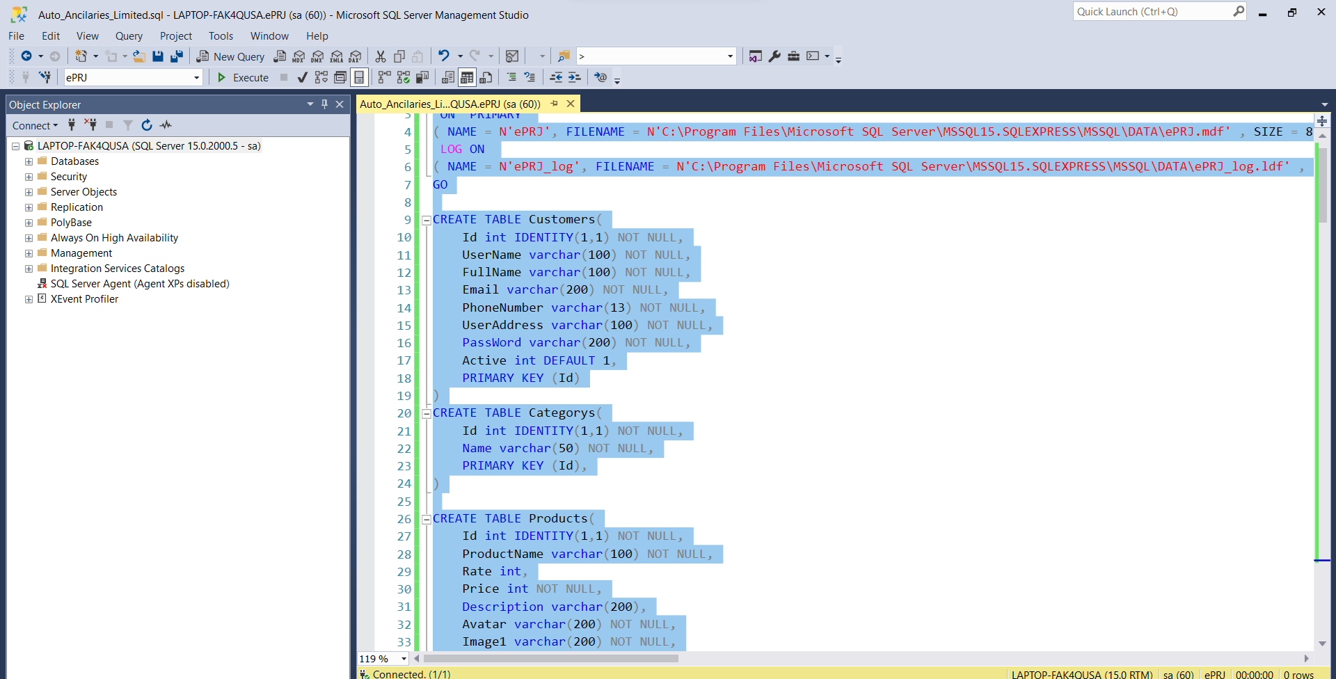

* Refesh database:

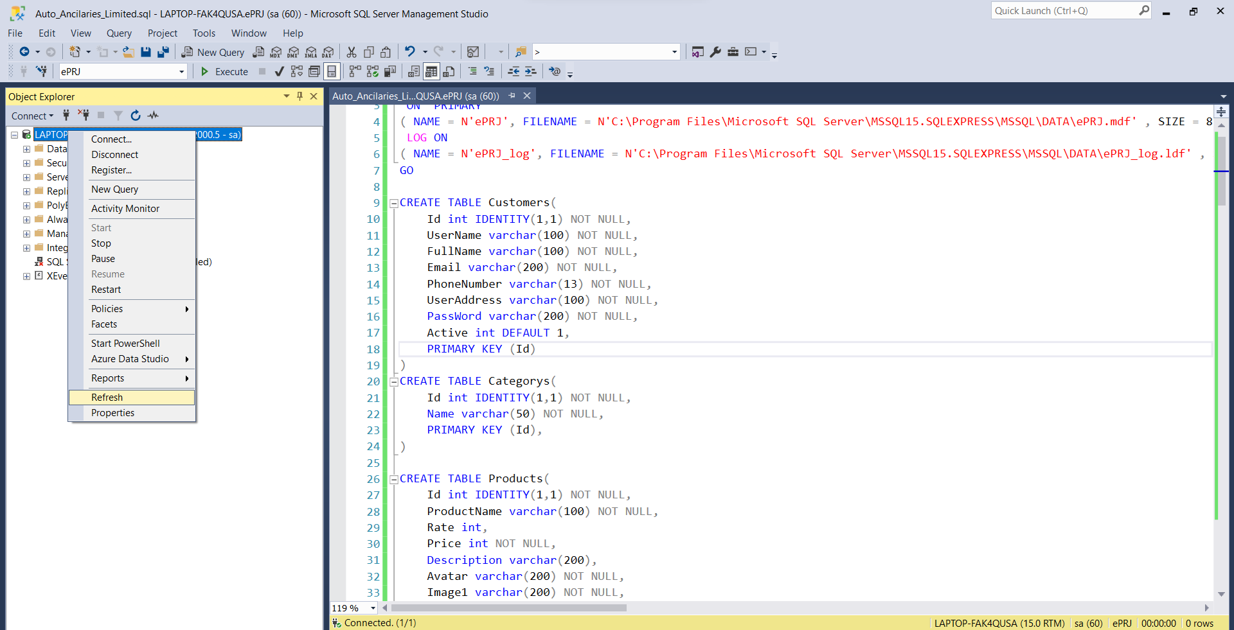

* The name of database  ***“ePRJ”*** will be displayed.

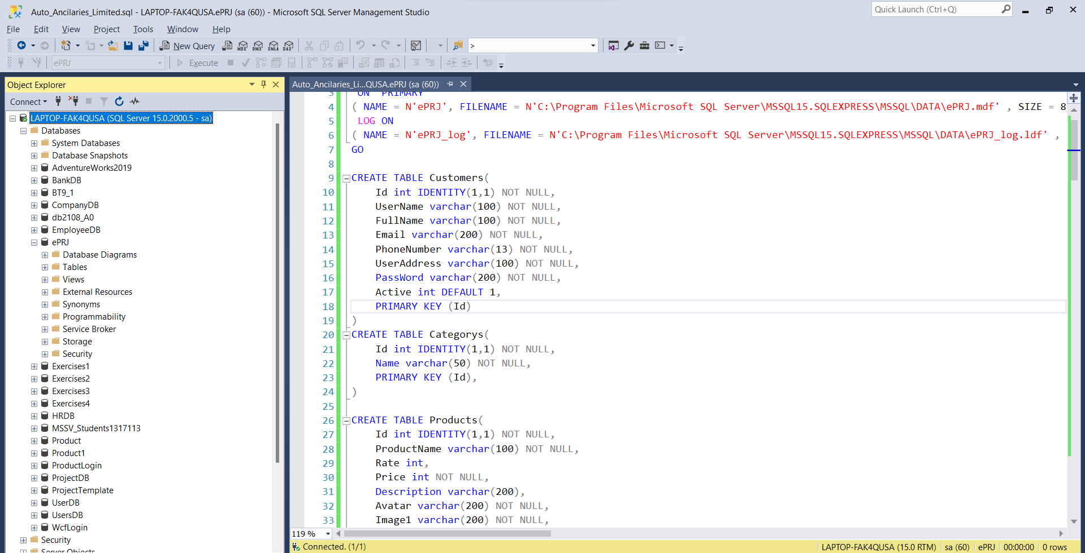

1. **Open Project**

* Open folder Group 6 – Auto Ancilaries Limited > src
* Double-click on ***Client.sln*** to open project in Microsoft Visual Studio 2019

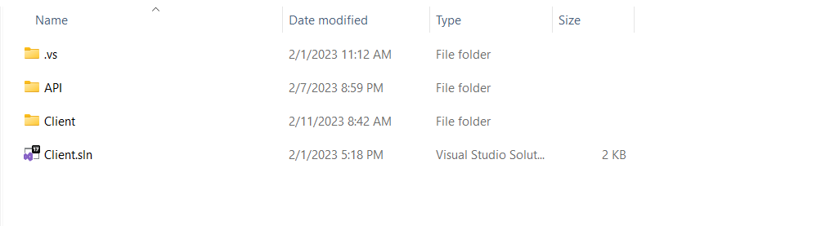

* Open Microsoft SQL Server Management Studio 18 and copy Server name

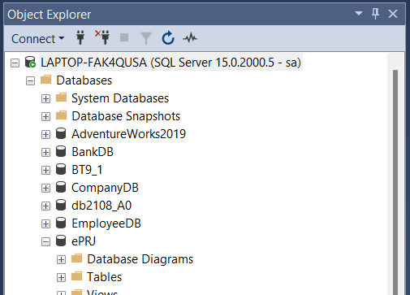

* In Client on Microsoft Visual Studio 2019 open appsetting.json file and paster Server Name

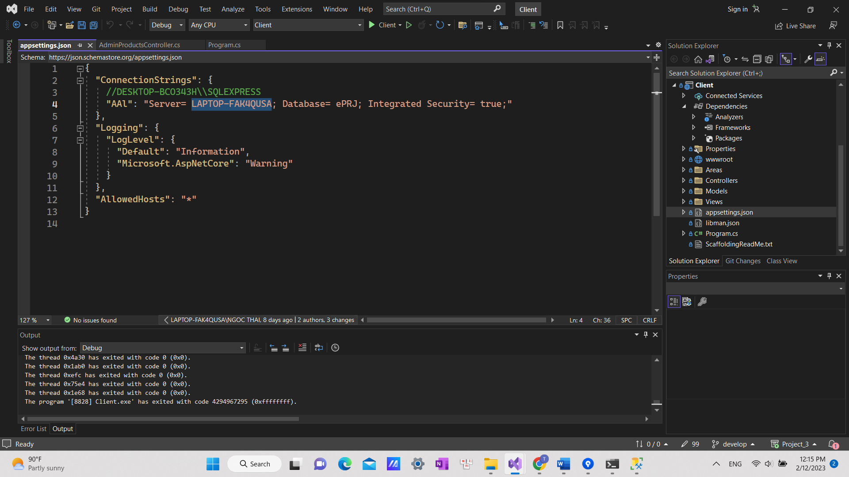

* In Program.cs

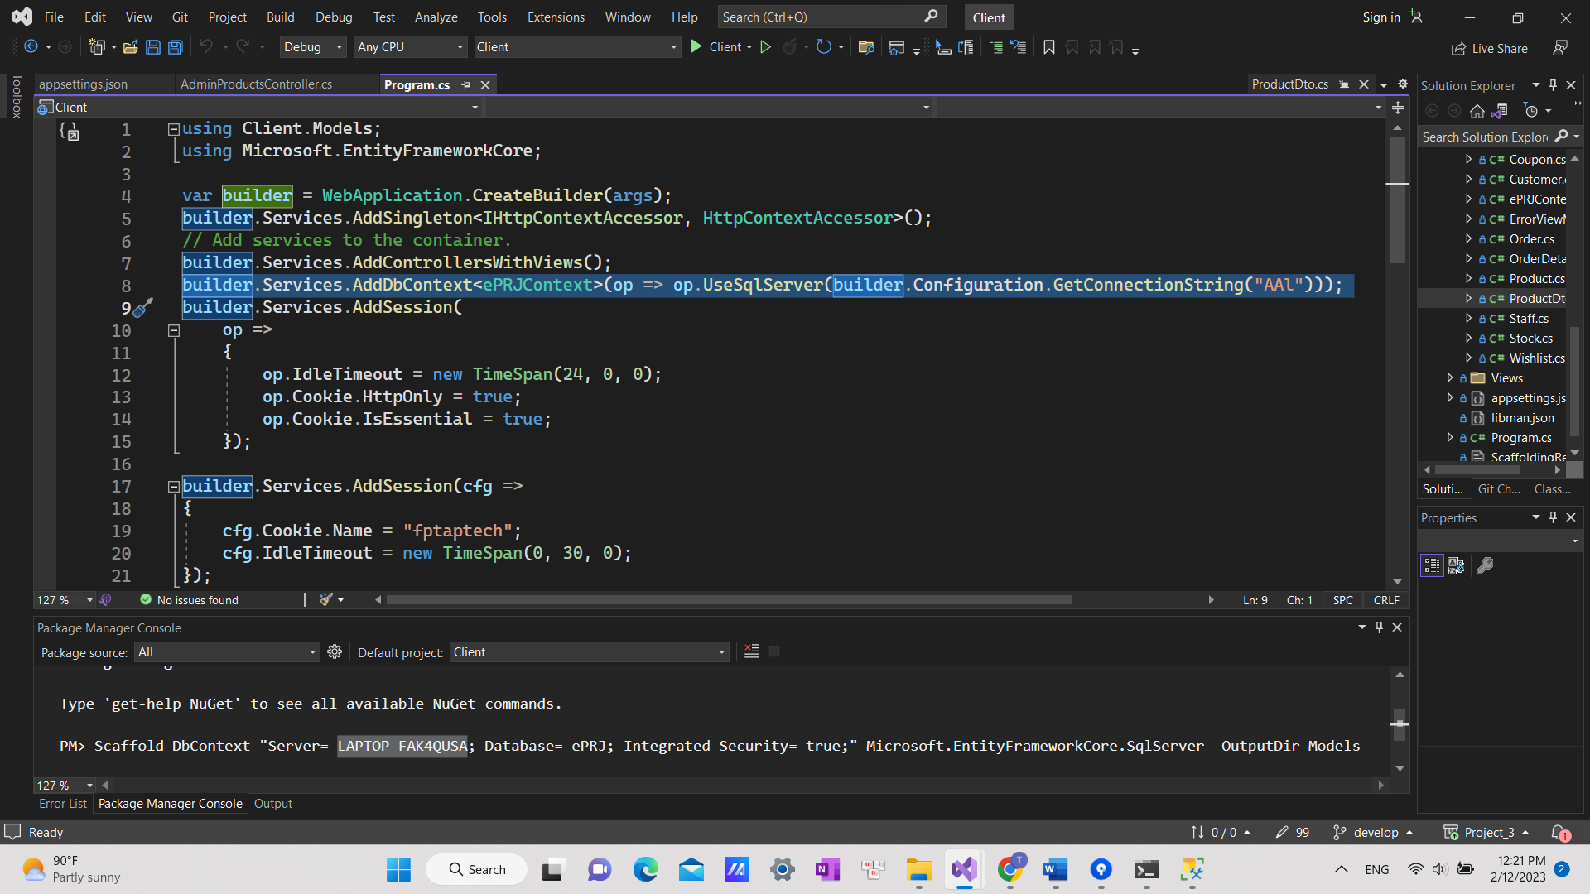

* In Microsoft Visual Studio, click on menu Build and select Build Solution:
* Wait for Successful message:

So you have finished the installation of our software. Congratulations on that. We are very honored to be able to guide you, thank you for keeping track!!

Note: You can use the accounts below to test:

1. Link to login admin: http://localhost:57649/Login/adLogin

Admin account : admin. Password: 123456

1. User account: Thai3. Password: 123

User account: Thai000. Password: 123